#Technical Design Document-Debug_exercise_1
#Student: Richard Crespo
#Date: January 28, 2026

#Program Summary:
This program processes a list of products, calculates discounts, applies them to each product’s price,
and prints the results. It includes validation and error handling so invalid data (such as a string
instead of a number) does not crash the program.

Function Summaries:

#calculate_discount(price, discount_rate)
- Purpose: Compute the discount amount with validation.
- Parameters:
price (int/float)
discount_rate (int/float)
- Variables:
discount_amount (float)
- Logic:
Validate types (must be numeric).
Validate values (must be nonnegative).
Multiply price × discount_rate.
- Returns: discount_amount (float)

#apply_discount(price, discount_amount)
- Purpose: Subtract discount from original price.
- Parameters:
price (int/float)
discount_amount (float)
- Variables:
new_price (float)
- Logic:
new_price = price - discount_amount
- Returns: new_price (float)

#main()
- Purpose: Controls program flow, loops through products, handles errors.
- Variables:
products (list of dicts)
name, price, discount_rate, discount_amount, final_price
- Logic:
Loop through each product.
Try to calculate and apply discount.
If invalid data, catch error and print message.
Continue to next product.
- Returns: None (prints output)

Debugging Report Summary:
- Issue: Program crashed with TypeError due to "500" being a string.
- Cause: Python cannot multiply a string by a float.
- How Found: PyCharm debugger showed price="500" during Tablet iteration.
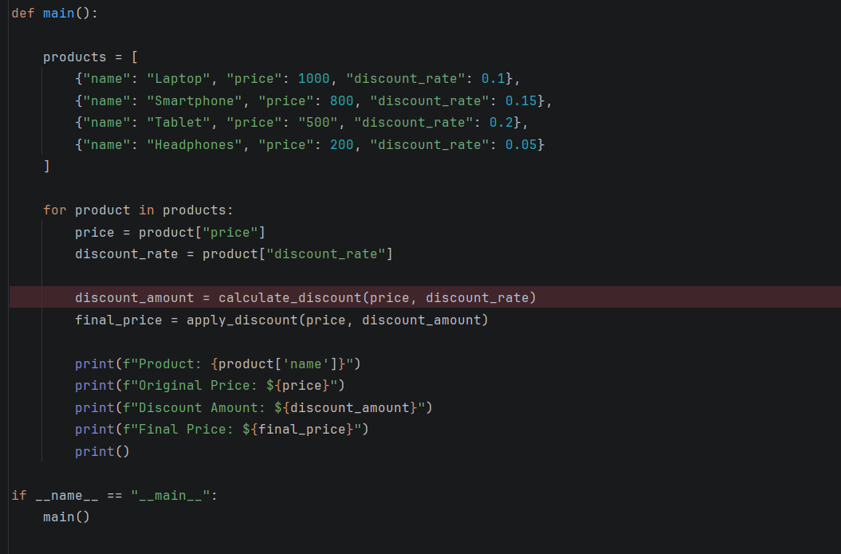

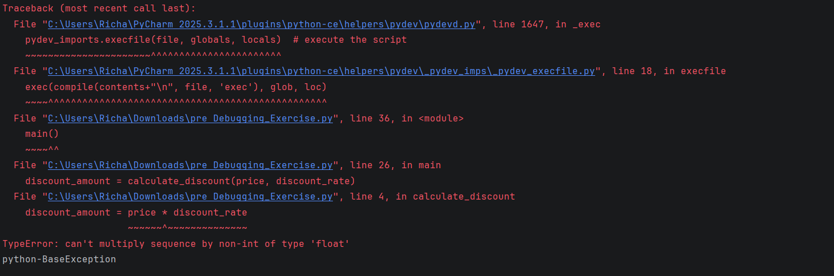
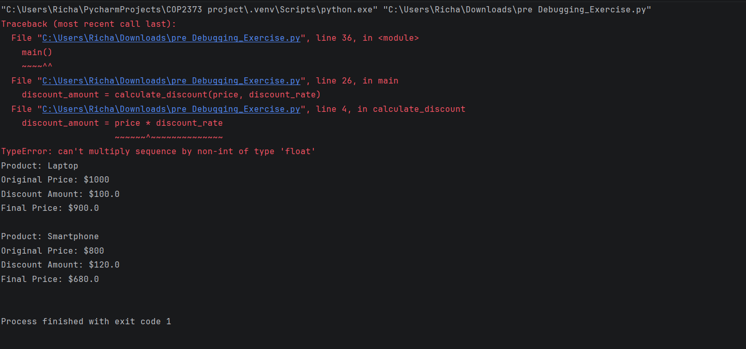
- Fix:
A. Added input validation in calculate_discount.
B. Added try/except in main to prevent crashing.
- Testing:
Valid products processed correctly.
Invalid product prints error message and program continues.
Picture of fixed results-
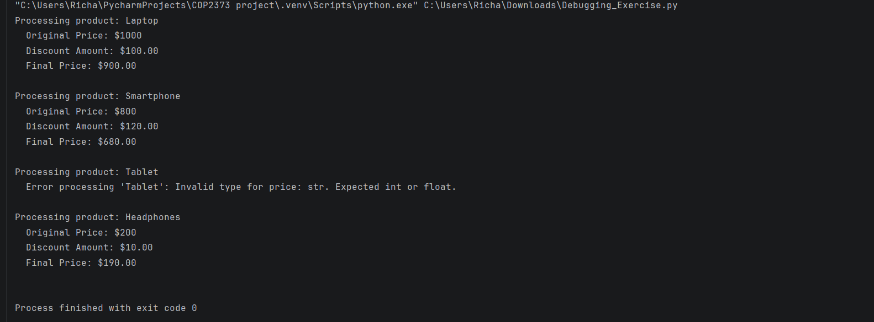
Link to repository- https://github.com/richardcrespo/COP2373_project/blob/master/Debugging_Exercise.py

